JFS Module 2 Notes
- Define Servlet. Explain how Servlet operates along with its advantages.
A Servlet is a server-side Java program that handles client requests and generates dynamic web content.
How Servlet Operates (Working of Servlet)
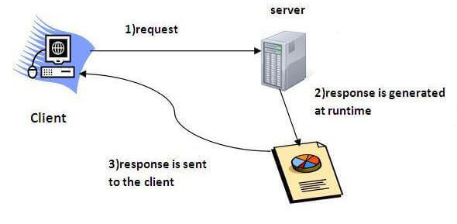
- Client Sends Request: User enters URL in browser and Browser sends HTTP request to web server
- Web Server Forwards Request: If request is for servlet, it is forwarded to the Servlet Container
- Servlet Container Processing:
If servlet is not loaded:
Container loads servlet class
Creates servlet object
Calls init() method (only once)
- Request Handling
For every request:
service() method is called
For HTTP servlets:
doGet() → Handles GET request
doPost() → Handles POST request
- Response Generation
Servlet processes business logic
Generates response using PrintWriter
Sends response back to browser
- Servlet Destruction
When server stops:
destroy() method is called
Servlet object is removed from memory
Advantages:
- Better performance: because it creates a thread for each request, not process.
- Portability: because it uses Java language.
- Robust: JVM manages Servlets, so we don't need to worry about the memory leak, garbage collection, etc.
- Secure: because it uses Java language.

- Explain the HTTP Request Methods in Servlet.
In Servlets, HTTP request methods are handled using the HttpServlet class.
When a client (browser) sends a request, the service() method internally calls the appropriate method like:
doGet() : Asks to get the resource at the requested URL.
doPost() : Asks the server to accept the body info attached. It is like GET request with extra info sent with the request.

doPut() : Says to put the enclosed info (the body) at the requested URL.
doDelete() : Says to delete the resource at the requested URL.
doHead() : Asks for only the header part of whatever a GET would return. Just like GET but with no body.
doOptions() : Asks for a list of the HTTP methods to which the thing at the request URL can respond
doTrace() : Asks for the loopback of the request message, for testing or troubleshooting.
- What is Servlet Container. Explain Servlet Container States.
A Servlet Container (also called Web Container) is a part of a web server that:
Manages Servlets
Handles client requests
Controls servlet life cycle
Provides security
Performs multithreading
Manages session tracking
and acts as a bridge between the Web Server and the Servlet.
which can be run in a separate process. We can classify the servlet container states in three types:
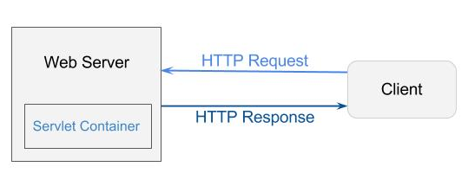
Standalone : It is typical Java-based servers in which the servlet container and the web servers are the integral part of a single program.
For example:- Tomcat running by itself.
In-process : It is separated from the web server, because a different program runs within the address space of the main server as a plug-in.
For example:- Tomcat running inside the JBoss.
Out-of-process : The web server and servlet container are different programs which are run in a different process. For performing the communications between them, web server uses the plug-in provided by the servlet container.
- What is servlet Interface . Explain methods in Servlet Interface with a example code.
The Servlet Interface is the core interface in the Java Servlet API.
It defines the life cycle methods that every servlet must implement.
All servlets either:
Directly implement the Servlet interface
OR
Extend classes like GenericServlet or HttpServlet (which internally implement Servlet interface)
Methods of Servlet Interface
public void init(ServletConfig config) :
initializes the servlet. It is the life cycle method of servlet and invoked by the web container only once.
public void service(ServletRequest request, ServletResponse response)
provides response for the incoming request. It is invoked at each request by the web container.
public void destroy()
is invoked only once and indicates that servlet is being destroyed.
public ServletConfig getServletConfig()
returns the object of ServletConfig
public String getServletInfo()
returns information about servlet such as writer, copyright, version etc.
Servlet Interface Example code :
import java.io.*;
import jakarta.servlet.*;
public class MyServlet implements Servlet {
private ServletConfig config;

// 1. init()
public void init(ServletConfig config)
throws ServletException {
this.config = config;
System.out.println("Servlet Initialized");
}

// 2. service()
public void service(ServletRequest request,
ServletResponse response)
throws ServletException, IOException {

response.setContentType("text/html");
PrintWriter out = response.getWriter();
out.println("<h1>Hello from Servlet Interface</h1>");
}

// 3. destroy()
public void destroy() {
System.out.println("Servlet Destroyed");
}

// 4. getServletConfig()
public ServletConfig getServletConfig() {
return config;
}

// 5. getServletInfo()
public String getServletInfo() {
return "MyServlet Version 1.0";
}
}
- What is GenericServlet Class. Explain the methods in GenericServlet Class.
The GenericServlet class is an abstract class in the Java Servlet API.
Which Implements the Servlet interface And Provides default implementations for most methods
Methods in GenericServlet Class are
- public void init(ServletConfig config)
is used to initialize the servlet.
- public abstract void service(ServletRequest request, ServletResponse response)
provides service for the incoming request. It is invoked at each time when user requests for a servlet.
- public void destroy()
is invoked only once throughout the life cycle and indicates that servlet is being destroyed.
- public ServletConfig getServletConfig()
returns the object of ServletConfig.
- public String getServletInfo()
returns information about servlet such as writer, copyright, version etc.
Example Program
import java.io.*;
import javax.servlet.*;
public class First extends GenericServlet {
public void service(ServletRequest req,ServletResponse res)
throws IOException, ServletException {
res.setContentType("text/html");
PrintWriter out=res.getWriter();
out.print("<html><body>");
out.print("<b>hello generic servlet</b>");
out.print("</body></html>");
}
}
- What is HttpServlet Class. Explain the methods in HttpServlet Class.
The HttpServlet class is an abstract class used to create HTTP-based web applications in Java.
It is part of the Java Servlet API and belongs to:
Methods of HttpServlet class
- public void service(ServletRequest req, ServletResponse res)
dispatches the request to the protected service method by converting the request and response object into http type.
- protected void service(HttpServletRequest req, HttpServletResponse res)
receives the request from the service method, and dispatches the request to the doXyz() method depending on the incoming http request type.
- protected void doGet(HttpServletRequest req, HttpServletResponse res)
handles the GET request. It is invoked by the web container.
- protected void doPost(HttpServletRequest req, HttpServletResponse res)
handles the POST request. It is invoked by the web container.
- protected void doHead(HttpServletRequest req, HttpServletResponse res)
handles the HEAD request. It is invoked by the web container.

- protected void doOptions(HttpServletRequest req, HttpServletResponse res)
handles the OPTIONS request. It is invoked by the web container.
- protected void doPut(HttpServletRequest req, HttpServletResponse res)
handles the PUT request. It is invoked by the web container.
- protected void doTrace(HttpServletRequest req, HttpServletResponse res)
handles the TRACE request. It is invoked by the web container.
- protected void doDelete(HttpServletRequest req, HttpServletResponse res)
handles the DELETE request. It is invoked by the web container.
- protected long getLastModified(HttpServletRequest req)
returns the time when HttpServletRequest was last modified since midnight January 1, 1970 GMT.
- Explain in brief Life cycle of a Servlet.
The Servlet Life Cycle describes the stages a servlet goes through from its creation to destruction inside the servlet container.
It is managed by the Java Servlet container (e.g., Apache Tomcat).
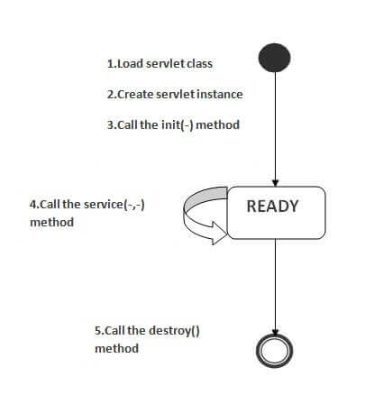
1) Servlet class is loaded
The classloader is responsible to load the servlet class. The servlet class is loaded when the first request for the servlet is received by the web container.
2) Servlet instance is created
The web container creates the instance of a servlet after loading the servlet class. The servlet instance is created only once in the servlet life cycle.
3) init method is invoked
The web container calls the init method only once after creating the servlet instance. The init method is used to initialize the servlet. It is the life cycle method of the javax.servlet.Servlet interface. Syntax of the init method is given below:
public void init(ServletConfig config) throws ServletException
4) service method is invoked
The web container calls the service method each time when request for the servlet is received. If servlet is not initialized, it follows the first three steps as described above then calls the service method. If servlet is initialized, it calls the service method. Notice that servlet is initialized only once. The syntax of the service method of the Servlet interface is given below:
public void service(ServletRequest request, ServletResponse response)
throws ServletException, IOException
5) destroy method is invoked
The web container calls the destroy method before removing the servlet instance from the service. It gives the servlet an opportunity to clean up any resource for example memory, thread etc. The syntax of the destroy method of the Servlet interface is given below:
public void destroy()
- Explain in detail Steps to Create a servlet.
The Steps to Create Servlet are as follows
- Create a directory structure :
The directory structure defines that where to put the different types of files so that web container may get the information and respond to the client.
- Create a Servlet :
There are three ways to create the servlet.
- By implementing the Servlet interface
- By inheriting the GenericServlet class
- By inheriting the HttpServlet class
- Compile the Servlet
For compiling the Servlet, jar file is required to be loaded. Different Servers provide different jar files:
Two ways to load the jar file
set classpath
paste the jar file in JRE/lib/ext folder
Put the java file in any folder. After compiling the java file, paste the class file of servlet in WEB-INF/classes directory.
- Create a deployment descriptor
The deployment descriptor is an xml file, from which Web Container gets the information about the servlet to be invoked.
- Start the server and deploy the project
To start Apache Tomcat server, double click on the startup.bat file under apache-tomcat/bin directory.
One Time Configuration for Apache Tomcat Server
set JAVA_HOME or JRE_HOME in environment variable (It is required to start server).
Change the port number of tomcat (optional). It is required if another server is running on same port (8080).
- Access the servlet
servlet can be accessed through the URL
http://localhost:8080/demo/welcome
- What is Servlet Request , Explain with a example Program.
A Servlet Request is an object that represents the client’s request to the server.
When a client (browser) sends a request, the servlet container creates a request object and passes it to the servlet.
index.html
<form action="welcome" method="get">
Enter your name<input type="text" name="name"><br>
<input type="submit" value="login">
</form>
welcome.java
import javax.servlet.http.*;
import javax.servlet.*;
import java.io.*;
public class welcome extends HttpServlet {
public void doGet(HttpServletRequest req,HttpServletResponse res) throws ServletException, IOException {
res.setContentType("text/html");
PrintWriter pw=res.getWriter();
String name=req.getParameter("name");//will return value
pw.println("Welcome "+name);
pw.close();
}
}
- What is RequestDispather in Servlet. Explain forward and include method
The RequestDispatcher interface provides the facility of dispatching the request to another resource it may be html, servlet or jsp. This interface can also be used to include the content of another resource also. It is one of the way of servlet collaboration.
There are two methods defined in the RequestDispatcher interface.
Methods of RequestDispatcher interface
The RequestDispatcher interface provides two methods. They are:
Farword Method : response of second servlet is sent to the client. Response of the first servlet is not displayed to the user
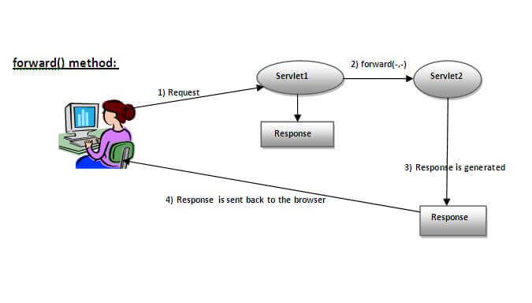
Syntax:
public void forward(ServletRequest request,ServletResponse response)throws ServletException, IOException:
Forwards a request from a servlet to another resource (servlet, JSP file, or HTML file) on the server.
Include Method : response of second servlet is included in the response of the first servlet that is being sent to the client.
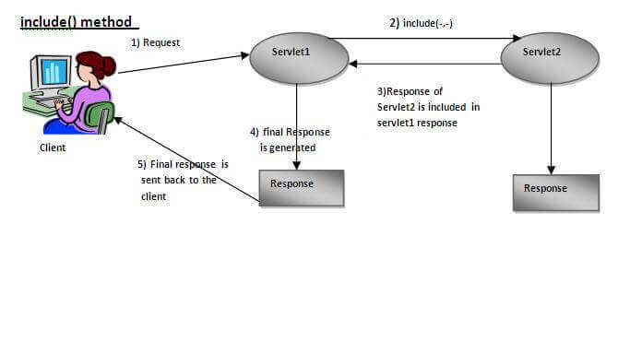
Syntax:
public void include(ServletRequest request,ServletResponse response)throws ServletException, IOException:
Includes the content of a resource (servlet, JSP page, or HTML file) in the response.
- With a example Program explain RequestDispather interface.
The getRequestDispatcher() method of ServletRequest interface returns the object of RequestDispatcher.
Syntax of getRequestDispatcher method
public RequestDispatcher getRequestDispatcher(String resource);
Example of using getRequestDispatcher method
RequestDispatcher rd=request.getRequestDispatcher("servlet2");
rd.forward(request, response);//method may be include or forward
Index.html
index.html
<form action="servlet1" method="post">
Name:<input type="text" name="userName"/><br/>
Password:<input type="password" name="userPass"/><br/>
<input type="submit" value="login"/>
</form>
Login.java
import java.io.*;
import javax.servlet.*;
import javax.servlet.http.*;
public class Login extends HttpServlet {
public void doPost(HttpServletRequest request, HttpServletResponse response) throws ServletException, IOException {
response.setContentType("text/html");
PrintWriter out = response.getWriter();
String n=request.getParameter("userName");
String p=request.getParameter("userPass");
if(p.equals("servlet") {
RequestDispatcher rd=request.getRequestDispatcher(“WelcomeServlet");
rd.forward(request, response);
}
else {
out.print("Sorry Password Error!");
RequestDispatcher rd=request.getRequestDispatcher("/index.html");
rd.include(request, response);
} } }
- Explain SendRedirect( ) in Servlet. Explain with a example Program.
The sendRedirect() method of HttpServletResponse interface can be used to redirect response to another resource, it may be servlet, jsp or html file.
It accepts relative as well as absolute URL.
It works at client side because it uses the url bar of the browser to make another request.
Example Program :
Index.html
<!DOCTYPE html>
<html>
<head>
<title>sendRedirect example</title>
</head>
<body>
<form action="MySearcher">
<input type="text" name="name">
<input type="submit" value="Google Search">
</form>
</body>
</html>
DemoServlet.java
import java.io.*;
import javax.servlet.*;
import javax.servlet.http.*;
public class DemoServlet extends HttpServlet{
public void doGet(HttpServletRequest req,HttpServletResponse res
throws ServletException,IOException {
res.setContentType("text/html");
PrintWriter pw=res.getWriter();
response.sendRedirect("http://www.google.com");
pw.close();
}}
Creating custom google search using sendRedirect
In this example, we are using sendRedirect method to send request to google server with the request data.

- What is Session Tracking. Explain in brief Session Tracking Techniques.
Session - a particular interval of time.
Session Tracking is a way to maintain state (data) of a user.
Http protocol is a stateless, so need to maintain state using session tracking techniques. Each time user requests to the server, server treats the request as the new request. So we need to maintain the state of a user to recognize to particular user.
There are four techniques used in Session tracking:
Cookies
A cookie is a small piece of information that is persisted between the multiple client requests.
A cookie has a name, a single value, and optional attributes such as a comment, path and domain qualifiers, a maximum age, and a version number
create cookie.
Cookie ck=new Cookie("user", “Rahul");//creating cookie object
response.addCookie(ck);//adding cookie in the response
delete Cookie
It is mainly used to logout or signout the user.
Cookie ck=new Cookie("user", "");//deleting value of cookie
ck.setMaxAge(0);//changing the maximum age to 0 seconds

get Cookies
Cookie ck[]=request.getCookies();
for(int i=0;i<ck.length;i++){
out.print("<br>"+ck[i].getName()+" "+ck[i].getValue());//printing name and value of cookie
}
Hidden Form Field
In case of Hidden Form Field a hidden (invisible) textfield is used for maintaining the state of a user.
In such case, we store the information in the hidden field and get it from another servlet. This approach is better if we have to submit form in all the pages and we don't want to depend on the browser.
Let's see the code to store value in hidden field.
<input type="hidden" name="uname" value=“Rahul">
URL Rewriting
URL rewriting, we append a token or identifier to the URL of the next Servlet or the next resource. We can send parameter name/value pairs using the following format:
url?name1=value1&name2=value2&??
A name and a value is separated using an equal = sign, a parameter name/value pair is separated from another parameter using the ampersand(&).

HttpSession
The HttpServletRequest interface provides two methods to get the object of HttpSession:
public HttpSession getSession(): Returns the current session associated with this request, or if the request does not have a session, creates one.
public HttpSession getSession(boolean create) : Returns the current HttpSession associated with this request or, if there is no current session and create is true, returns a new session.
- What is URL Rewriting explain with a example Program.
URL rewriting, we append a token or identifier to the URL of the next Servlet or the next resource. We can send parameter name/value pairs using the following format:
url?name1=value1&name2=value2&??
A name and a value is separated using an equal = sign, a parameter name/value pair is separated from another parameter using the ampersand(&).
Advantage of URL Rewriting
It will always work whether cookie is disabled or not.
Extra form submission is not required on each pages.
Disadvantage of URL Rewriting
It will work only with links.
It can send Only textual information.
Example Program :
index.html
<form action="servlet1">
Name:<input type="text" name="userName"/><br/>
<input type="submit" value="go"/>
</form>
FirstServlet.java
import java.io.*;
import javax.servlet.*;
import javax.servlet.http.*;
public class FirstServlet extends HttpServlet {
public void doGet(HttpServletRequest request, HttpServletResponse response){
try{
response.setContentType("text/html");
PrintWriter out = response.getWriter();
String n=request.getParameter("userName");
out.print("Welcome "+n);
s out.print("<a href='servlet2?uname="+n+"'>visit</a>");
out.close(); }
catch(Exception e){System.out.println(e);
} } }

